CMP6200

Individual Undergraduate Project (FYP) Final Report

New Ways to Play: A Study in Alternative Game Controllers

Student Name: Zorik Rostam
Student ID: 23149743

Course: BSc (hons) Computer Game Technology
Supervisor: Richard Davies
Date: 5th May 2026

Table of Contents

New Ways to Play: A Study in Alternative Game Controllers 1
  - Introduction and Context 4
  - Problem Statement 4
  - Review of Existing Knowledge 4
Technical Development 4
Immersion 5
Alternative Game Controllers 5
Immersion in games 5
  - Critical Analysis and Gap Identification 6
  - Project Justification 7
  - Project Aims, Objectives, and Scope 7
  - Project Aim 7
  - Project Objectives 8
  - Project Scope 8
  - Project Design 8
  - Design and Methods 9
  - Justification of Methods 9
  - Project Timeline 10
  - Feasibility, Risks, and Ethical Aspects 11
  - Feasibility 11
  - Risk Analysis and Mitigation 11
  - Ethical Considerations 12
References 12
List of Figures
Figure 1 - game controllers used 6
Figure 2 - Gantt Chart Project Timeline 10
List of Tables
Table 1 - Risk Assessment and Mitigation 12

Introduction and Context
This report aims to discuss and explore alternative input methods that can shape gameplay, immersion, and player experience. The interaction that the player has while playing a game in terms of the player experience is significantly influenced by the input device they use (Akyaman & Alppay, 2024). The aim is to develop a game around the controller that will also be developed over time during the project phase. This report will also be: exploring the importance of alternative controllers such as VR, adaptive hardware and motion controls; how they can affect accessibility; and helping to investigate the hardware advantages, disadvantages and sustainability of input methods; and looking at how the layout, ergonomics, functionality can influence player experience and immersion as well as how it can be beneficial for those who can't use traditional controllers.

Problem Statement
Current gaming hardware such as controllers are dominated by large corporations that standardize, non-sustainable practices that are often prone to failures like stick drift and require a lot of plastic, which makes them major contributors to environment impact and expensive to produce. This creates a barrier to entry for cost conscious developers to create a more sustainable form of gaming by eliminating unnecessary materials, shipping costs, and resources.

The project's aim is to not re-invent input devices but to explore the development of alternative game controllers. develop, explore and study alternative game controllers and how it will help with the project to produce an alternative game controller that can be more sustainable and cost efficient to develop and educate users how there are many other forms of controllers there are and not just traditional ones. This will help by becoming a more sustainable form of gaming by eliminating any unnecessary materials, shipping cost and resources. Most players find that these alternative game controllers do not actually give them an advantage when playing games or even feel immersed (Thorpe, et al., 2011).
Large corporations developing expensive hardware, due to increased market prices, lose out on a large percentage of players that may not be able to afford them; this leaves them highly susceptible to other 3rd party (small to medium sized) companies to develop controllers that can further improve the players’ experience, knowing they are using a controller worth investing in to use long term. EEG-based technology (another alternative form of game controller particularly connected with virtual reality) has become more popular which means having to meet player demands such as wearability, price, portability and ease of use (Thorpe, et al., 2011).

Review of Existing Knowledge

Technical Development
Alternative game controllers have been around for many years from the popularity of motion controls such as the Nintendo Wii and Kinect to more advanced technology like Virtual Reality which allows the user to essentially be in a world of their own which can track full human interaction. A lot of these alternative game controllers still use the traditional buttons and joysticks but more have started using as little as possible and mostly dependant on motion control and non-traditional inputs. This also comes with setbacks where a lot of

users found that having traditional buttons was a lot better than using virtual reality as the technology still requires a lot of work to fully work as fast as possible (Steed & Lai, 2025).

Immersion
Immersion refers to a person having full engagement on the task they are focused on. (Cambridge Dictionary, 2025) This can be related to the project because players can be so immersed in the game, they can lose track of time and lack awareness of real-world time and surroundings. There are different forms of immersion such as sensory, challenge based, narrative immersion etc.
But the form of immersion that will be focused on in this report will be how alternative game controllers can help with the players’ experience and immersion within video games.

Alternative Game Controllers
Immersion is a focal point in the game industry whether that's how often players can turn their devices on to play a game or how long they can sit and play.
Games that want to offer a high degree of immersion have taken this into consideration. Consoles like the XBOX 360 gamepad and the Nintendo Wii remote were judged mediocre for increased immersion, even though the Wii
remote was new form of tech which makes use of motion control that is meant to increase player experience and immerse the player within the game (Thorpe, et al., 2011). These are aspects that a lot of game studios have in mind when developing their games. There is also the physical form equipment that contributes to these forms of immersion for players, and one of the most important aspects is the input system that allows players to be immersed in the games they play. Having a comfortable controller is just as important as being able to play the game.

Immersion in games
However, articles, reports and online stats show that having alternative game controllers does not actually improve the immersion or player experience in games as much or even necessarily make them feel like they have an advantage. (Thorpe, et al., 2011). But this also means that the game being played needs to support these different forms of alternative game controllers such as VR, motion controls and make sense when being used. The right input method can possibly improve the game and player experience. (Thorpe, et al., 2011). Further research, as seen in Figure 1 below, shows that when playing a game, players are willing to use the traditional gamepad instead of the alternative controllers such as motion controls or VR.

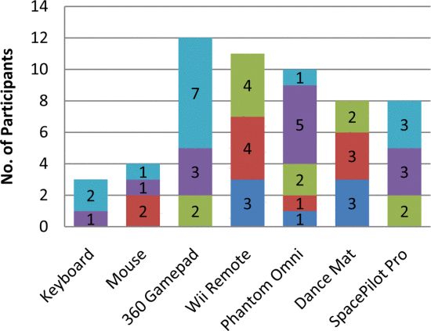
Figure 1 - game controllers used

Critical Analysis and Gap Identification
This report has covered alternative game controllers and how and why they are used to potentially improve player experience and immersion. However, using reports to support these statements, it is clear to see that these studies fail to explore how alternative game controllers could potentially have risks or failures, and how alternative game controllers affects the game they play and why it may ruin the player’s experience.
Most examples of these alternative game controller reports have focused on using a range of sensory perceptions, including touch or haptics, to boost immersion, attention, multimodal representations, and multi-channel processing of information and VR (Jakubowicz, 2024).
However, the identified key gaps in research are:
    - The potential for risks that people may suffer from these alternative game controllers.
    - The lack of consumer needs most people prefer to use regular gamepads instead of VR or motion controls when gaming.
    - Players’ early frustration when using alternative game controllers, and how they may not be familiar using the hardware.
    - Research often assumes players with full range of motion or perfect vision and hearing.
    - Environmental impacts, and how creating these alternative game controllers may cost a lot to produce and contain a lot of unnecessary materials.
The gaps within the research on alternative game controllers have many similarities and the research suggests that a lot will be needed to consider when

developing the hardware and can make the player experience much more immersive and much better experience overall.

Project Justification
It is important to build on the gaps that are in the research such as lack of studies on environmental impacts, potentially wasting materials to produce these high-end hardware and cost of production. Players that use these alternative controllers, such as VR or motion controls, may feel frustrated because they may not know how to use them or even players who may not know some of the limitations that comes with some of the hardware, and they may not be able to fully use these functions.
The core idea behind the project, which will fill in the gaps, will be a controller that will be developed to be a part of a game and will be developed alongside each other. This will ensure that the controller works effectively and can help players understand the hardware behind these features such as motion controls or haptic feedback that can support players who may not be able to or want to use the traditional joystick or button on gamepads. The gaps that are in the research will be eliminated by ensuring reduced costs. Also, reduced materials will be used during the development of this project. This will be achieved by using an Arduino kit that provides with all the necessary parts and materials required to support this project.
The project outcome is that it can help players learn and understand how to use some of these alternative game controllers and be ready for future hardware such as VR, Motion controls, etc. which will help other companies potentially increase their consumer numbers. They will be more aware of the hardware capabilities and potentially encourage other large corporates to do their own further research into the gaps missing within their own studies.

Project Aims, Objectives, and Scope
During this project there will be aims, objectives and scopes that will need to be followed to ensure the project goes all as planned. This will be done with bullet points in each section showing what will be done to ensure the best possible result for the overall project success.

Project Aim
The aim of this project is to develop an input method in the form of an Arduino-based kit to capture the mechanics and process inputs to emphasize the unique affordance of the controller.

Project Objectives
Set out 4-6 specific objectives that break down the project aim into smaller tasks, that are: Specific, Measurable, Achievable, Relevant and Time-bound (SMART).
    - Objective 1: Research focused to establish knowledge foundation
    - Objective 2: Technical implementation building the input system
    - Objective 3: Gameplay design integration, creating the game around the input system.
    - Objective 4: Prototype completion, have a playable build
    - Objective 5: User testing and evaluate experience
    - Objective 6: Analysis and documentation

Project Scope
This project will concentrate on alternative input methods which will help the user capture the full experience of the hardware, such as motion control. Another focus will be researching and prototyping while also developing a game that will help understand this hardware. This project will not be developing multiple input systems or full-scale commercial game.

Project Design
The project is to build an alternative game controller for a game that will be developed alongside, to showcase how immersion and player experience can be shaped. To ensure the best possible results, there will be methods, tools and schedules that will need to be closely used and followed. The game controller will be developed by using an Arduino starter kit which can run code to help interact with real physical world such as motion controls. The kit comes with breadboard, wires, sensors and other components to support in design and code physical
electronic equipment to support the project (Arduino Store, 2025) . Unity will be used to design the actual game that will help showcase the input device, using scripts like C# in Visual Studio and ensuring the work is version controlled using GitHub Desktop. Using these tools will help ensure the best possible results as they are very well received tools universally for coding and developing hands on hardware.
The schedule that will be followed is the Gantt chart below in Figure 2 which will follow a close weekly pattern that will ensure the correct dates and project phases are being completed. Along with weekly meetings with the tutor who will support along the project phases.

Design and Methods
The overall approach of this project will be taken very cautiously and will involve multiple experiments and development phases which will help produce the best results. Designing and prototyping an input system game controller along with a software integration will clearly demonstrate the results of the alternative game controller. Development of the Unity game will be used as a test environment.
The aim is to evaluate player immersion and experience using the custom designed controller. Even though the project requires a functional build of the input system and unity game, the results still require statistical analysis and data gathering to show the project works and provides the required goal to achieve immersion and player experience. This project will involve gathering data such as quantitative data like response times, reliability, number of successful inputs.
Data qualitative data will also be used, such as user feedback, observation notes about how the player felt and the ease of use and immersion. Design data will be considered, determining if the input system writing schematics are effective and ensuring the sensor calibrations and ensure Unity input mappings are correctly working as intended.
When designing and building the custom game controller, the Arduino kit for prototyping will be used, as it effectively gives all the parts required to design this project, offering a variety of wires, sensory technology, circuit design on breadboard and code in the Arduino IDE.
Along with the game controller, the Unity-Based game will be needed to work simultaneously along with the Arduino kit using Visual studio C# to create gameplay responding to the inputs. Using custom input mapping with Unity built in Input Map this should help with connecting the hardware signals to in game actions.

Justification of Methods
The approach that has been decided during the development of this project has been picked out carefully to ensure the best possible results. The approach will be using hardware and tools such as Arduino Kit which is known to be a very user friendly and great starting kit to produce prototypes for electronics and programming for the best and quickest results. Development with Unity also has been universally well received, as it is used by a lot of indie developers to produce some of the best games today. Unity in-built support for versatile input mapping is exactly what is required to develop input system and work seamlessly with the Arduino kit.

Arduino Kits have a lot of different components and utilities that all have their own specifications that are useful for projects. This will help ensure that the project objectives are being completed, as well as offer the flexibility and compatibility of Arduino Kits. The information that is available, with the hardware, software and resources online, will be very helpful to ensure that the results are effective. The same can be said for Unity, a well-known brand name for many years, having lots of developers and studios use their engine and seamless
integration and support with C# Visual Studio allowing for the best compatibility for input mapping. There is also multiple sources and helpful guides online which can help with objectives of the project.

Project Timeline
New Ways to Play: A Study in Alternative Game Controllers
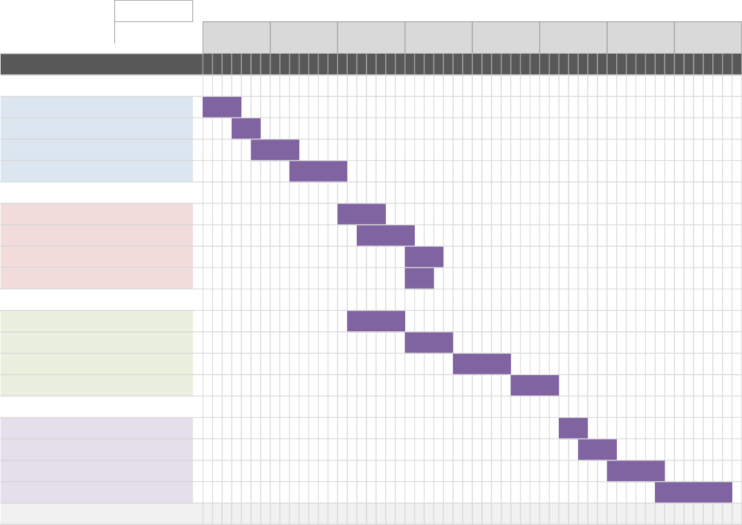
Mamud Rostam
Mon, 03/11/2025
3 Nov 2025
10 Nov 2025
17 Nov 2025
24 Nov 2025
1 Dec 2025
8 Dec 2025
15 Dec 2025
22 Dec 2025
3 4 5 6 7 8 9 10 11 12 13 14 15 16 17 18 19 20 21 22 23 24 25 26 27 28 29 30 1 2 3 4 5 6 7 8 9 10 11 12 13 14 15 16 17 18 19 20 21 22 23 24 25 26 27 28
Find Arduino Kit
3/11/25 6/11/25
Insert new rows ABOVE this one
20/12/25 30/12/25
complete prototype
15/12/25 20/12/25
Internal testing
12/12/25 15/12/25
Optimized and calibrated
10/12/25 12/12/25
Gather Participants
Prototype Completion Phase
5/12/25 9/12/25
Prototyping
29/11/25 4/12/25
User Interface
24/11/25 28/11/25
Code works
18/11/25 23/11/25
Game Design
Gameplay Design Phase
24/11/25 26/11/25
Development and Test
24/11/25 27/11/25
Unity Setup
19/11/25 24/11/25
Arduino Programming
17/11/25 21/11/25
Assemble Arduino
Technical Implementation Phase
12/11/25 17/11/25
Research project
8/11/25 12/11/25
Resource Plan
6/11/25 8/11/25
Game Engine
Research Phase
S
S
F
T
W
T
M
S
S
F
T
W
T
M
S
S
F
T
W
T
M
S
S
F
T
W
T
M
S
S
F
T
W
T
M
S
S
F
T
W
T
M
S
S
F
T
W
T
M
S
S
F
T
W
T
M
END
PROGRESS START
TASK
1
Figure 2 - Gantt Chart Project Timeline

Feasibility, Risks, and Ethical Aspects

Feasibility
When considering the projects to produce, researching (and later developing a new way to play and how alternative game controllers can effectively have an impact on players’ experience and immersion) was the best choice due the ability of existing coding knowledge and working with hardware such as Arduino Kit and scripting wouldn’t come with much of a challenge. The hardware and tools being considered for this project phase have a good reputation and are easily accessible due to low prices for anyone who wants to produce a product. The project can be easily achieved within the time limit given, with the help of the Gantt chart in Figure 2 showing each phase and how the project will ensure that it stays within the time limit and completes all phases as intended on time.

Risk Analysis and Mitigation
With a project that requires testing, prototyping and ensuring the results are successful, there will be loads of hardware malfunctioning that will be expected and communication errors between the Arduino and Unity. This could come in the form of software bugs or potential errors in the code as well, which will then require close attention to fix and not occur again. Furthermore, to stop these issues, it will be important to use backups and GitHub to ensure that projects are easily saved, recovered and controlled with ease. Early testing and checking-in with the paired supervisor should ensure for a smooth project.

Potential Risk | Likelihood (Low/Med/High) | Impact (Low/Med/High) | Mitigation Strategy
Hardware malfunctioning, due to faulty Arduino Kit  or damage | Medium | High | Identify the best Arduino Packs and researching previous users experiences to ensure best possible outcome.
Errors in the code when developing a seamless interaction between Arduino kit and Unity | Medium | Medium | Allocate time into  tutorials and guides and seeking guidance with supervisor.
Finding participants that are willing to take part in the project as test  subjects | Low | High | Look for individuals that are willing to take part in testing the product, online or real life early.

Table 1 - Risk Assessment and Mitigation

Ethical Considerations
During this project, there will be a lot of aspects of human interaction and having to make sure that the development of the project needs to be ethically considered, as well as how this can also be thought through. This project will ensure that the products being used are ethically sustainable, such as the Arduino kit and Unity, and when using human participants for feedback and gameplay testing, ensuring that they are all-informed consenting, and the data they give must be well protected and anonymised. The data handling will be done on paper as this is a much easier process and later, when scrapped, can be easily wiped out without leaving traces ensuring the participants identities are anonymous. The project will follow academic guidelines and any information used will be correctly credited.

References
Akyaman, S. & Alppay, E. C., 2024. Effects of industrial design properties of game controllers on player experience. [Online]
Available at:
https://www.sciencedirect.com/science/article/abs/pii/S1875952124000557 [Accessed 01 11 2025].
Arduino Store, 2025. Arduino Hardware. [Online] Available at: https://www.arduino.cc/en/hardware [Accessed 01 11 2025].
Cambridge Dictionary, 2025. Immersion. [Online]
Available at: https://dictionary.cambridge.org/dictionary/english/immersion [Accessed 31 10 2025].
Jakubowicz, S., 2024. Embodied Game Interactions: Somatosensation, Self-Identification, and the Potential of Alternative Game Controllers. [Online]
Available at: https://link.springer.com/chapter/10.1007/978-3-031-74138-8_41 [Accessed 31 10 2025].
Steed, A. & Lai, J., 2025. Comparison of hand tracking-based and controller-based interaction in a consumer virtual reality game. Virtual Reality, 29(3), p. 120.

Thorpe, A., Ma, M. & Oikonomou, A., 2011. History and alternative game input methods. [Online]
Available at: https://ieeexplore.ieee.org/abstract/document/6000321 [Accessed 31 10 2025].

